## Department of Computer Science & Engineering

**CSL76: BIG DATA LABORATORY TERM: Sep2022- Jan2022**

# SPARK REPORT

***By***

# Manoj Kumar M 1MS19CS086

**Submitted to**

# Dr. S. Rajarajeswari Assistant Professor

## M S RAMAIAH INSTITUTE OF TECHNOLOGY

**(Autonomous Institute, Affiliated to VTU)**

**BANGALORE-560054**

[**www.msrit.edu**](http://www.msrit.edu/)

2022

**SPARK**

**Installation Steps:**

1. Verifying Java Installation

-Use the command: java --version

1. Downloading Apache Spark

Download the latest version of Spark by visiting the following link Download Spark https://spark.apache.org/downloads.html . Select the latest version in Spark release and select pre-built for Apache Hadoop 3.2.2 and later. Click on the Download Spark link. It will navigate to one more page, and use HTTP to download the file. After downloading it, you will find the Spark tar file in the download folder.

1. Create a new Folder inside Desktop, name the Folder as your USN

<1ms19cs068>.

4 . Move the Downloaded Spark File to USN <1ms19cs068> Folder.

1. Right Click on that File and Extract inside the USN <1ms19cs068> Folder.
2. Open Terminal

Navigate to Extracted Hadoop Folder cd ~/Desktop/<1ms18cs068>/spark-3.3.0-bin- hadoop3

1. Create a New File named Bash.sh
2. Copy the Below code and Paste inside Bash.sh and save that File.

export JAVA_HOME=$(readlink -f $(which javac) | awk 'BEGIN {FS="/bin"} {print $1}') if ! command -v spark-shell --version &> /dev/null

then

export PATH=$(echo $PATH):$(pwd)/bin

1. Execute the bash.sh File using following command source Bash.sh. NOTE: Make source before compiling or running spark compile this file.
2. Verify JAVA_HOME variable to be set to Java Path and PATH variable has your USN Spark Folder.If any previous PATH set to Spark Folder remove that inside

.bashrc file.

1. Verify Hadoop is Installed or not by executing spark-shell --version command.if command gives Information about Hadoop command then Hadoop is Successfully Installed.

Execute all spark python files with spark-submit<python_filename>.py <inputFile>

<outputfolder>

**PROGRAMS**

1. **Write a spark to analyze the given weather report data and to generate a report with cities having maximum temperature for a particular year**

import sys if(len(sys.argv)!=3):

print("Provide Input File and Output Directory") sys.exit(0)

from pyspark import SparkContext sc =SparkContext()

f = sc.textFile(sys.argv[1])

temp=f.map(lambda x: (int(x[15:19]),int(x[87:92]))) maxi=temp.reduceByKey(lambda a,b:a if a&gt;b else b) maxi.saveAsTextFile(sys.argv[2])

**Output:**

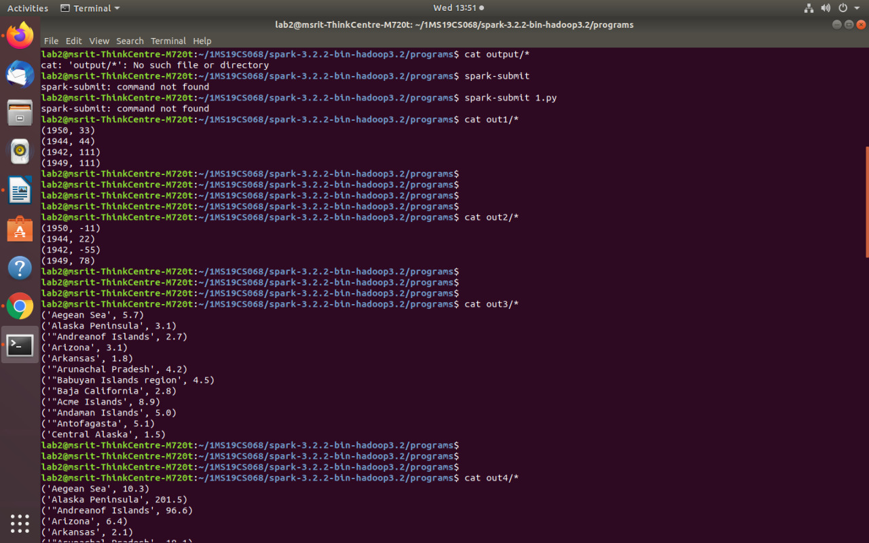

1. **Write a spark to analyze the given weather report data and to generate a report with cities having minimum temperature for a particular year**

import sys if(len(sys.argv)!=3):

print("Provide Input File and Output Directory”) sys.exit(0)

from pyspark import SparkContext sc =SparkContext()

f = sc.textFile(sys.argv[1])

temp=f.map(lambda x: (int(x[15:19]),int(x[87:92]))) mini=temp.reduceByKey(lambda a,b:a if a&lt;b else b) mini.saveAsTextFile(sys.argv[2])

**Output:**



1. **Write a spark program to analyze the given Earthquake data and generate statistics with region and magnitude**

import sys if(len(sys.argv)!=3):

print("Provide Input File and Output Directory”) sys.exit(0)

from pyspark import SparkContext sc =SparkContext()

f = sc.textFile(sys.argv[1])

temp=f.map(lambda x: (x.split(&#39;,&#39;)[11],float(x.split(&#39;,&#39;)[8]))) maxi=temp.reduceByKey(lambda a,b:a if a&gt;b else b) maxi.saveAsTextFile(sys.argv[2])

**Output:**



1. **Write a spark program to analyze the given Earthquake data and generate statistics with region and depth**

import sys if(len(sys.argv)!=3):

print("Provide Input File and Output Directory") sys.exit(0)

from pyspark import SparkContext sc =SparkContext()

f = sc.textFile(sys.argv[1])

temp=f.map(lambda x: (x.split(&#39;,&#39;)[11],float(x.split(&#39;,&#39;)[9]))) maxi=temp.reduceByKey(lambda a,b:a if a&gt;b else b) maxi.saveAsTextFile(sys.argv[2])

**Output:**

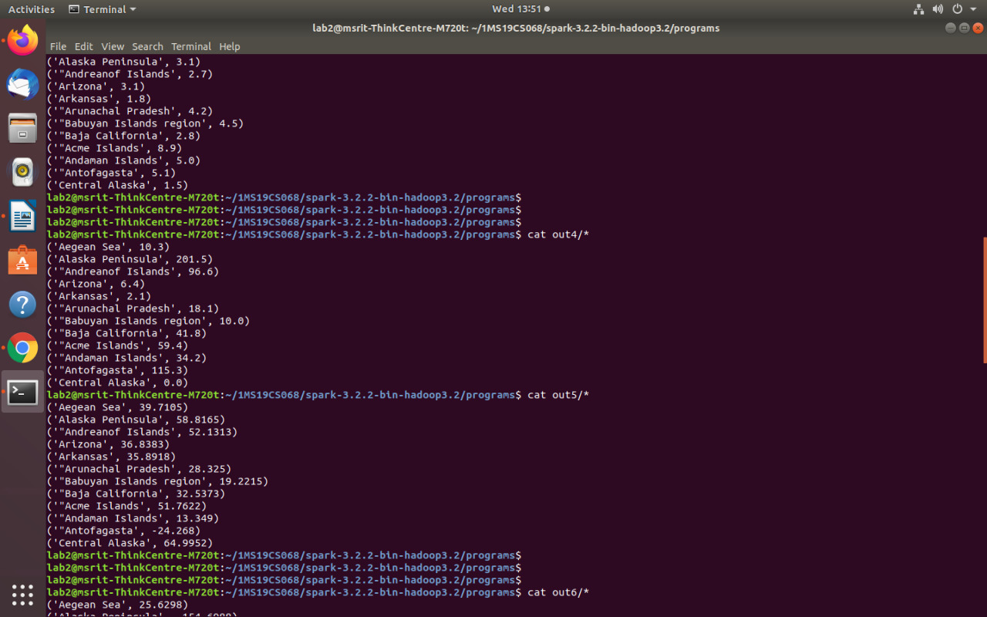

1. **Write a spark program to analyze the given Earthquake data and generate statistics with region and latitude**

import sys if(len(sys.argv)!=3):

print("Provide Input File and Output Directory") sys.exit(0)

from pyspark import SparkContext sc =SparkContext()

f = sc.textFile(sys.argv[1])

temp=f.map(lambda x: (x.split(&#39;,&#39;)[11],float(x.split(&#39;,&#39;)[6]))) maxi=temp.reduceByKey(lambda a,b:a if a&gt;b else b) maxi.saveAsTextFile(sys.argv[2])

**Output:**



1. **Write a spark program to analyze the given Earthquake data and generate statistics with region and longitude**

import sys if(len(sys.argv)!=3):

print("Provide Input File and Output Directory”) sys.exit(0)

from pyspark import SparkContext sc =SparkContext()

f = sc.textFile(sys.argv[1])

temp=f.map(lambda x: (x.split(&#39;,&#39;)[11],float(x.split(&#39;,&#39;)[7]))) maxi=temp.reduceByKey(lambda a,b:a if a&gt;b else b) maxi.saveAsTextFile(sys.argv[2])

**Output:**

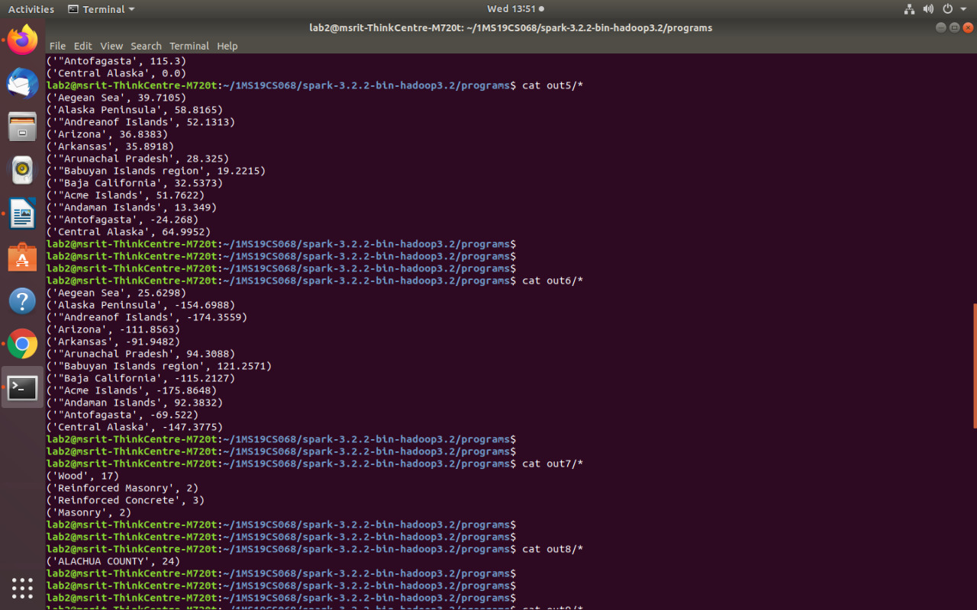

1. **Write a spark program to analyze the given Insurance data and generate a statistics report with the construction building name and the count of building.**

import sys if(len(sys.argv)!=3):

print("Provide Input File and Output Directory”;) sys.exit(0)

from pyspark import SparkContext sc =SparkContext()

f = sc.textFile(sys.argv[1])

temp=f.map(lambda x: (x.split(&#39;,&#39;)[16],1))

data=temp.countByKey() dd=sc.parallelize(data.items())

dd.saveAsTextFile(sys.argv[2])

**Output:**



1. **Write a spark program to analyze the given Insurance data and generate a statistics report with the county name and its frequency.**

import sys if(len(sys.argv)!=3):

print("Provide Input File and Output Directory”) sys.exit(0)

from pyspark import SparkContext sc =SparkContext()

f = sc.textFile(sys.argv[1])

temp=f.map(lambda x: (x.split(&#39;,&#39;)[2],1)) data=temp.countByKey() dd=sc.parallelize(data.items()) dd.saveAsTextFile(sys.argv[2])

**Output:**

